1. Write a program that will accept an integer and execute one of the following based on the input using IF statements:
   1. If 0, display only “Hello World”.
   2. If 1, display only “I am Groot”.
   3. If 2, display only “To the Top”.
   4. If 3, display only “Where is the horizon”.
   5. If 4, display only “I do not know”.
   6. If none of the above, display only “Yeah, I will.”.

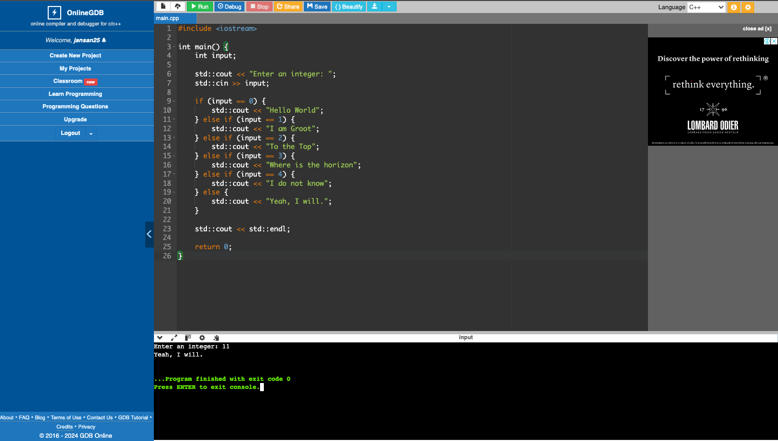

1. Write a program that will accept an integer and execute one of the following based on the input using SWITCH statements:
   1. If 0, display only “Hello World”.
   2. If 1, display only “I am good”.
   3. If 2, display only “To the Top”.
   4. If 3, display only “Where is the horizon”.
   5. If 4, display only “I do not know”.
   6. If none of the above, display only “Yeah, I will.”.

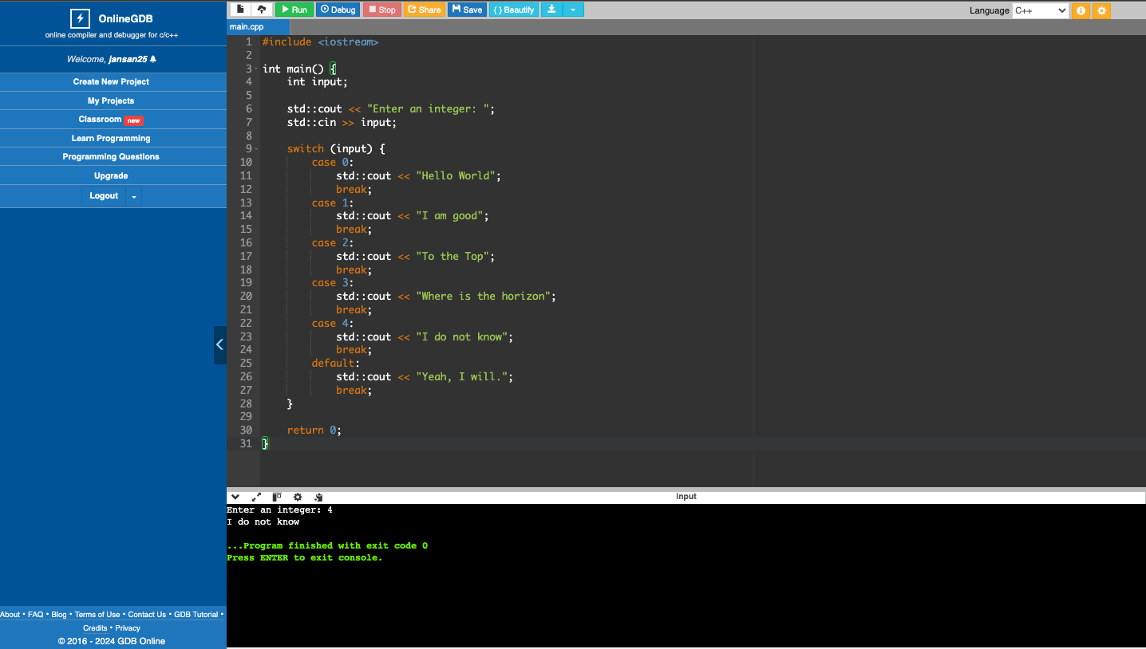

1. Write a program that will divide the two floating points entered by the user (first number entered divided by the second number entered). Make sure your application handles all possible scenarios with floating points.

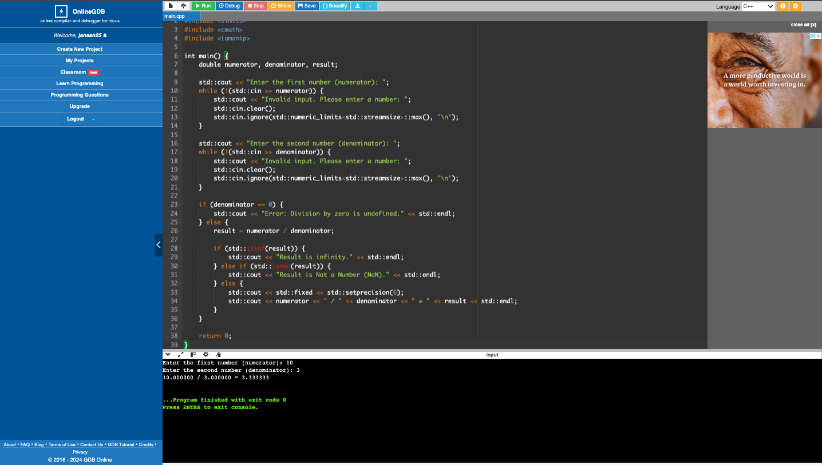

1. What can you conclude from this activity?

For decimal numbers, use float or double instead of int. Integers can't store or display decimal places, while floating-point types can accurately represent numbers with fractional parts.